|  |  |
| --- | --- |
|  | LAB 7: Introduction to RIP Protocol using Packet Tracer. |
|  |  |
|  | Akshar Panchani ID- 202101522  IT304 Computer Networks  10/17/23 |



**Exercise:**

**1.3:**

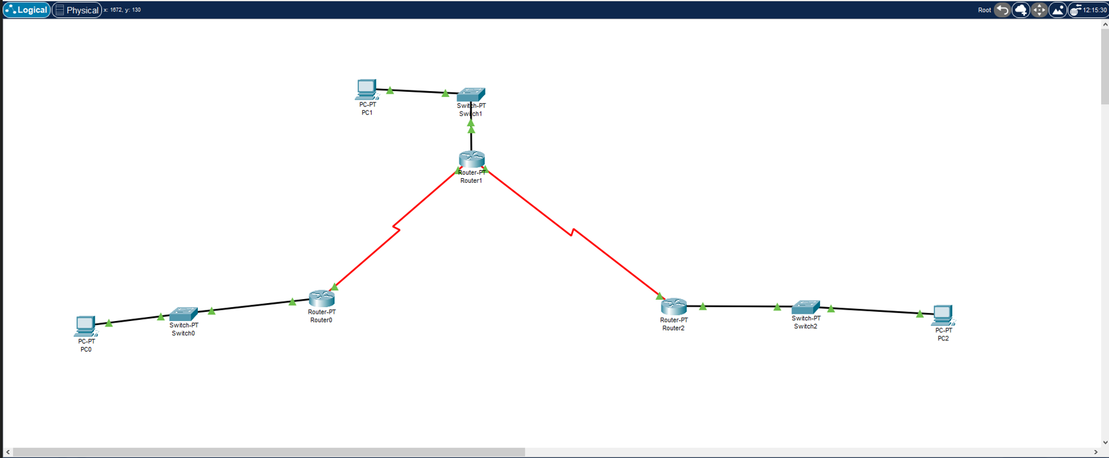

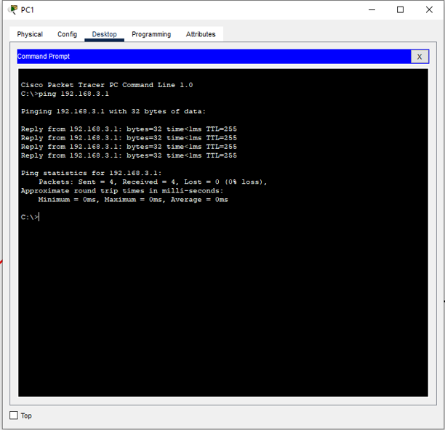

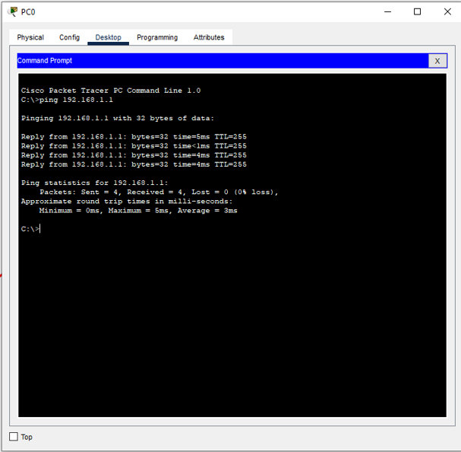

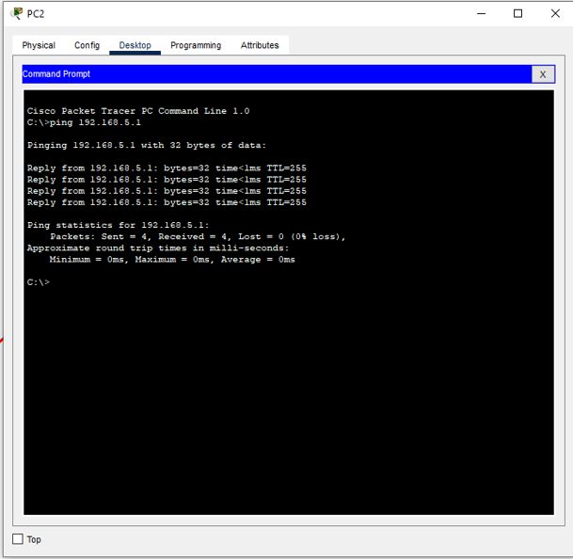

1. Display the output generated at step 5 and what is the maximum number of hops seen in the output?

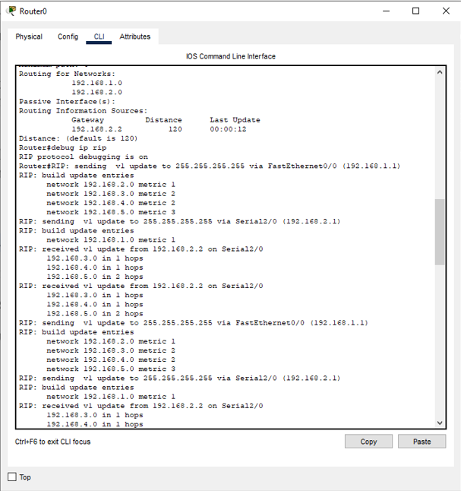

Maximum number of hops in output = 2 hops.

2. What is the administrative distance of RIP in Step 7?

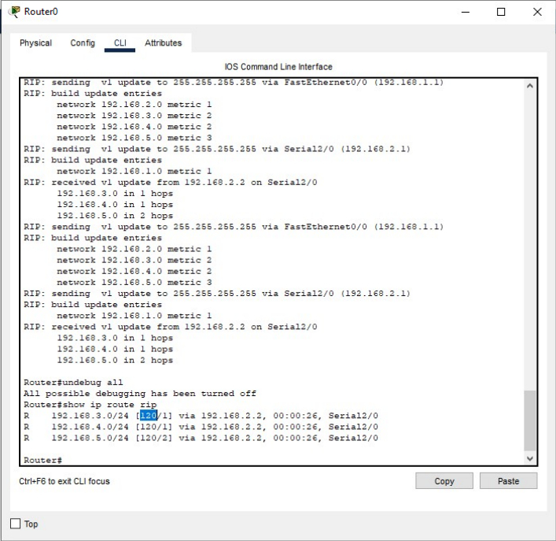

Administrative distance RIP = 120.

3. When was the last update you saw in Step 8?

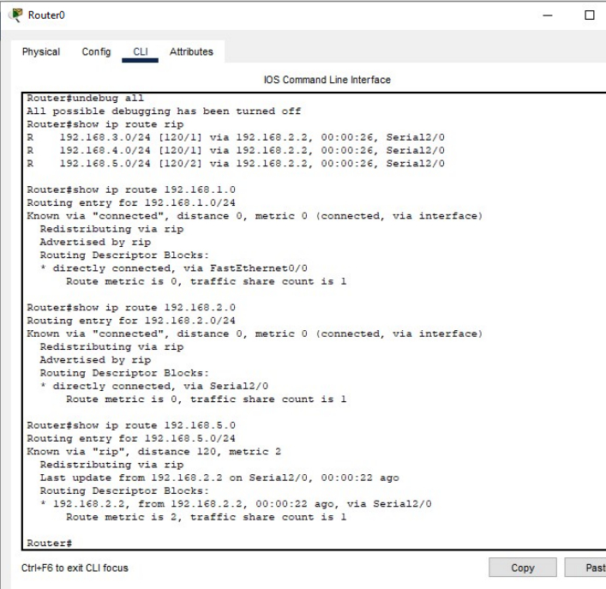

Last update = 22 seconds ago.

4. What is the default update time for RIP in Step 8?

Default update time RIP = 30 seconds.